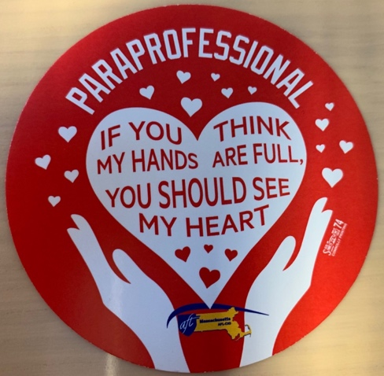

Paraprofessional Appreciation Day 2022

Words cannot express the deep gratitude we have for our paraprofessionals in Lynn. In this difficult time of educator shortages in all areas: teachers, therapists, and paraprofessionals, they have worked diligently with our students in many capacities. Many paraprofessionals have stepped into the teaching role to cover for teachers out on leaves. Our lunch paraprofessionals have served our children meals throughout the pandemic, whether we were in-person or remote families received meals for their children. Our paraprofessionals have been flexible in meeting the needs of the students in their buildings. My deepest appreciation for every paraprofessional working to support our students, teachers, and families.

THANK YOU, PARAPROFESSIONALS EVERYWHERE!!!!!

SHEILA O’NEIL – LYNN TEACHERS UNION, LOCAL 1037

